**Insilico system Biology**

**Laboratory file**

**Experiment 7 – to study the model organism using SABIO RK.**

**Submitted by – Meenu Dhama**

**Roll no. – 004**

**EXPERIMENT 7**

**Aim:** To search data and models of yeast glycolysis in SABIO-RK database

**URL:** http://sabio.h-its.org/

**THEORY:** SABIO-RK is a curated database containing structured information about biochemical reactions and their corresponding kinetics. It describes participants and modifiers of the reactions, as well as measured kinetic data (including kinetic rate equations) embedded in their experimental and environmental context. The system offers standardized data for metabolic and newly also signaling reactions by the use of controlled vocabularies and annotations pointing to other resources and biological ontologies. It enables the access to kinetic data for experimentalists and modellers. Thereby, SABIO-RK facilitates the exchange of the data between experimentalists and modellers, supporting the setup of quantitative computer models.

**PROCEDURE:**

* The Search field offers free text search.

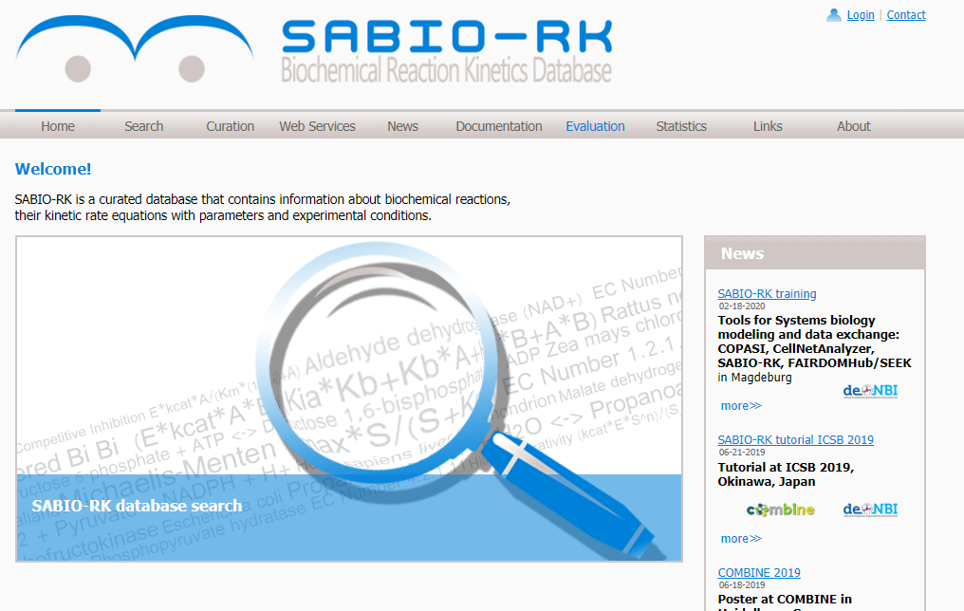

* The search result is represented by default in the Entry View, which is a table containing overview information of the database entries sorted by Sabio EntryID.
* We take reaction of Saccharomyces cerevisiae.

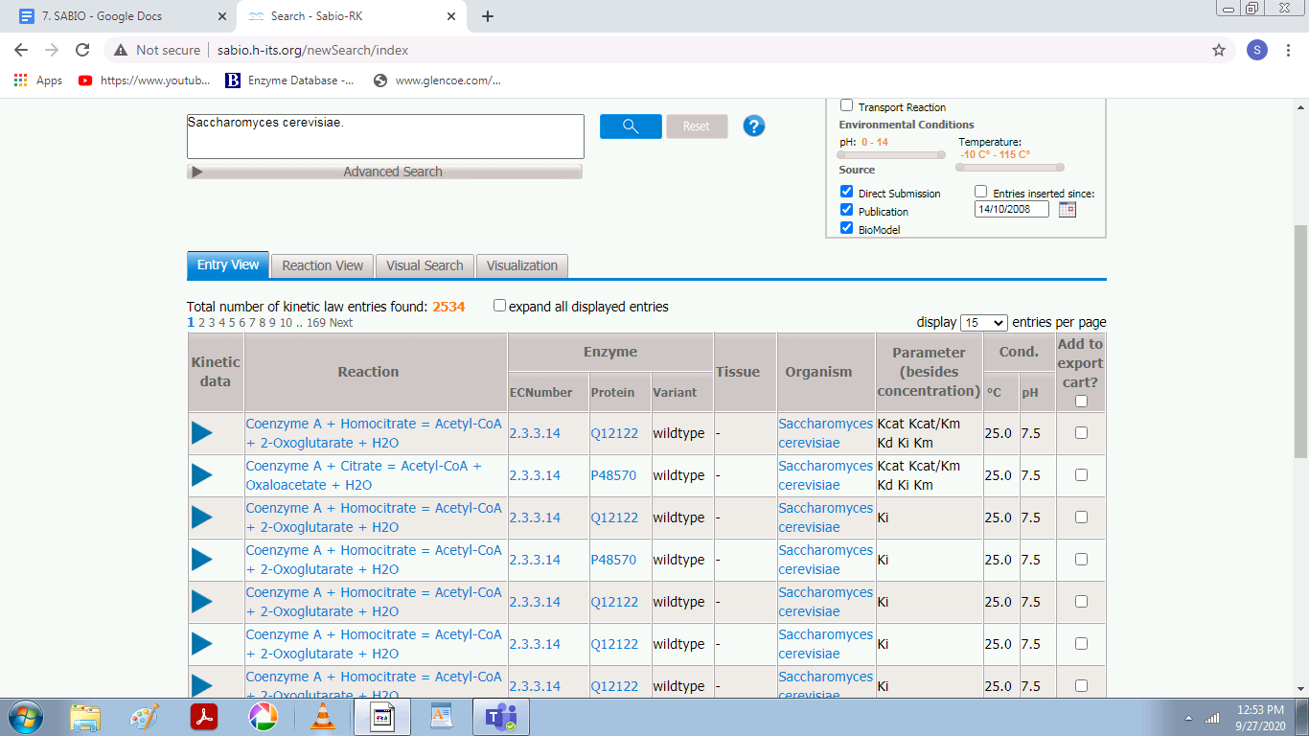

* Detailed information is given in the single database entries which can be displayed by clicking on the blue triangle to open an entry. Alternatively all entries can be opened at once by selecting “expand all displayed entries”.

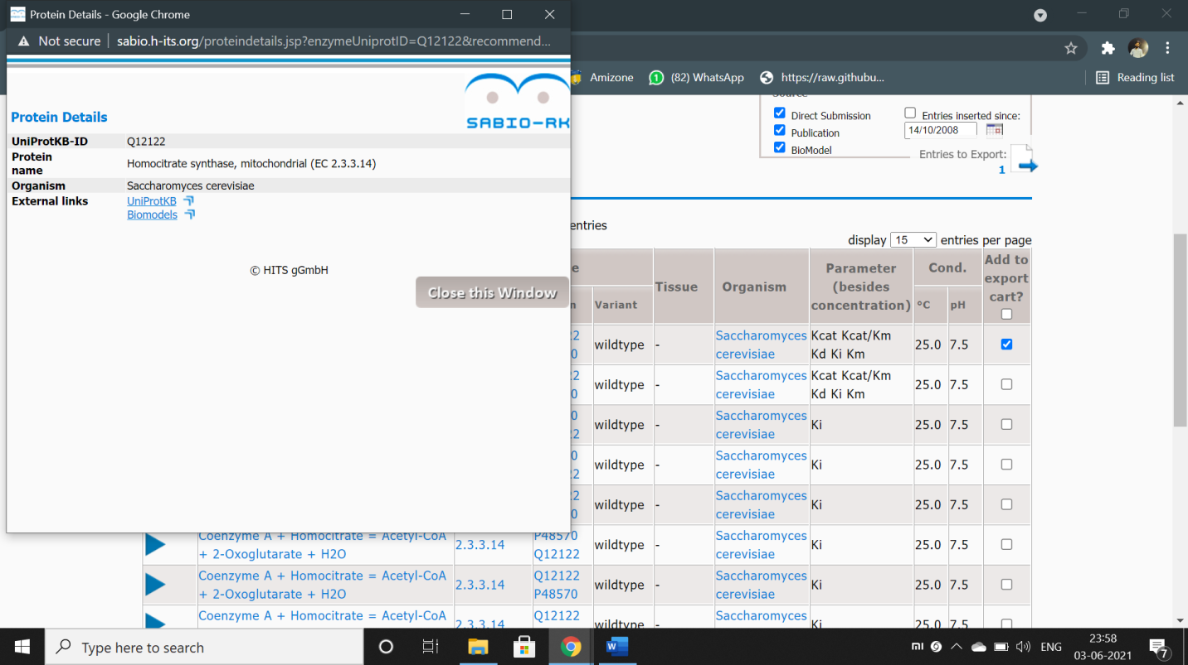

Figure – details about the protein.

* Now to see the reaction view we click on reaction view and then we click on the “click here to visualise option”.
* By clicking on each option, we can see details about themindividually.

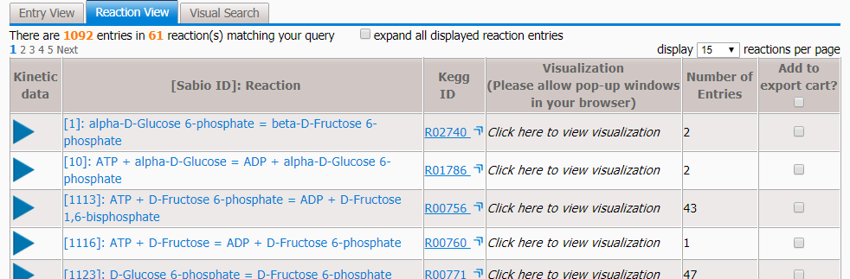

* Reaction View table which groups the entries based on the biochemical reaction.
* To get a quick impression about a certain reaction and to understand the connections between reaction, enzymes, organisms, and tissues a visualization is available.

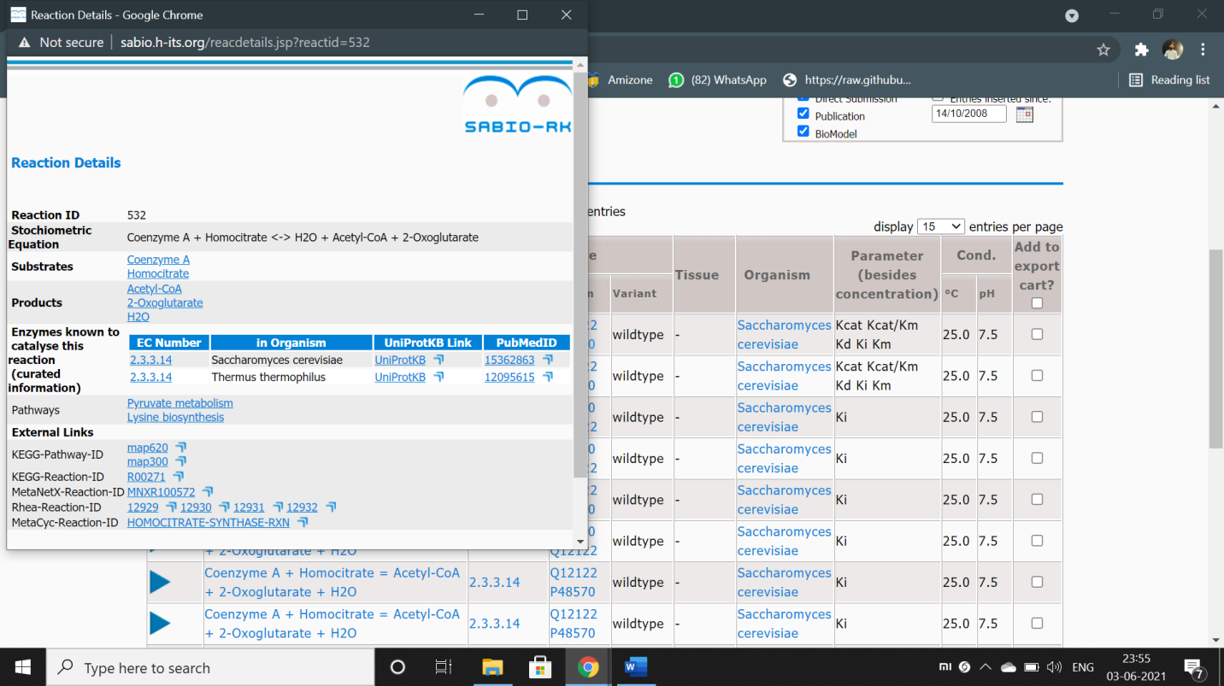

**Visual Search:**

Finally Visual Search gives a visual overview of the Search Result together with the opportunity to confine the search, e.g. to an organism, a tissue or a special kind of kinetic parameter or kinetic rate law.

There are various parameters taken into account and can observe them in “Visual Search”.

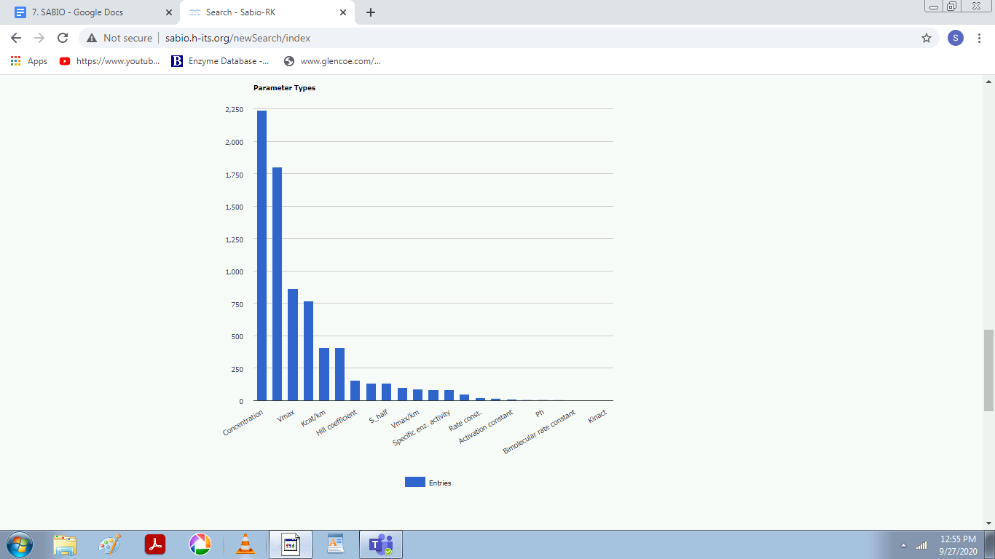

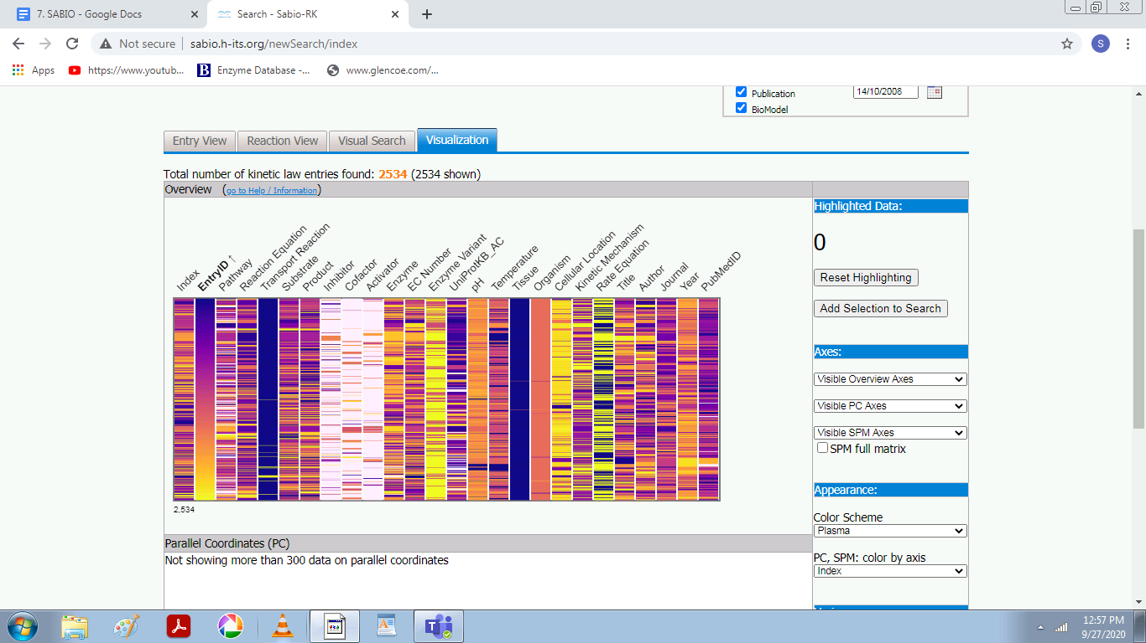

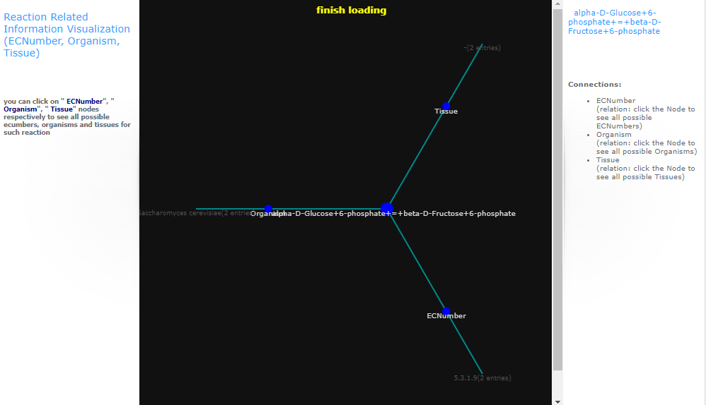

**Data Export:**

* To export data in SBML, BioPAX, or spreadsheet format entries can be selected either in the Entry View or Reaction View by clicking the checkbox.
* Selected entries are stored in the Export Cart.

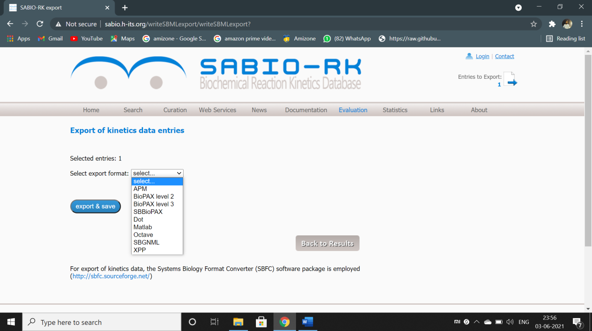

Figure – data export formats supported by SABIO RK.

* By clicking on “Entries to Export” a table gives an overview about selected entries for export in SBML, BioPAX or spreadsheet format.

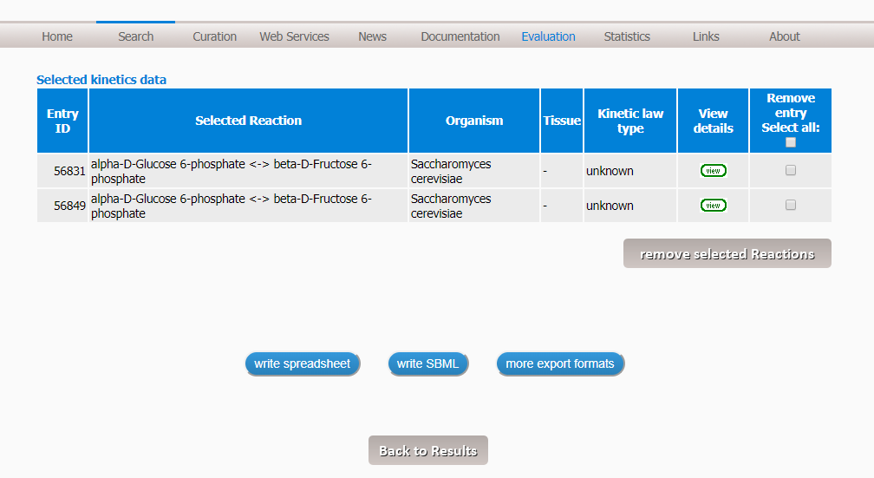

There are three different exports methods: Write spreadsheet, SBML, and BioPAX

**Write spreadsheet** allows to export the data in a table format (xls or tsv).

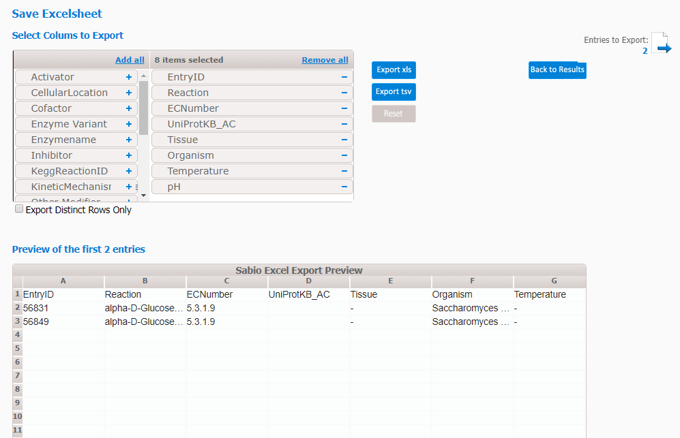

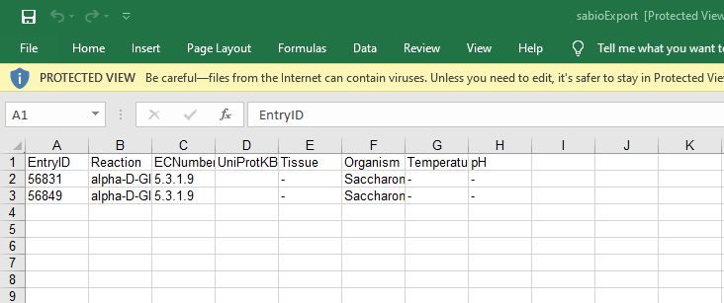

**Write SBML** allows to export the selected entries as a model in the Systems Biology Markup Language (SBML)-format or as pdf. Different SBML versions and annotation schema could be selected and a user-defined name could be given to the SB 